**Interpreter Vs Compiler**

Source Code

Source code refers to high level code or assembly code which is generated by human/programmer. Source code is easy to read and modify. It is written by programmer by using any High Level Language or Intermediate language which is human-readable. Source code contains comments that programmer puts for better understanding

source code is a set of instructions/commands and statements which is written by a programmer by using a computer programming language like C, C++, Java, Python, Assembly language etc

Machine Code

Computer does not understand high-level language. It only understands the program written in 0's and 1's in binary, called the machine code.

To convert source code into machine code, we use either a compiler or an interpreter.

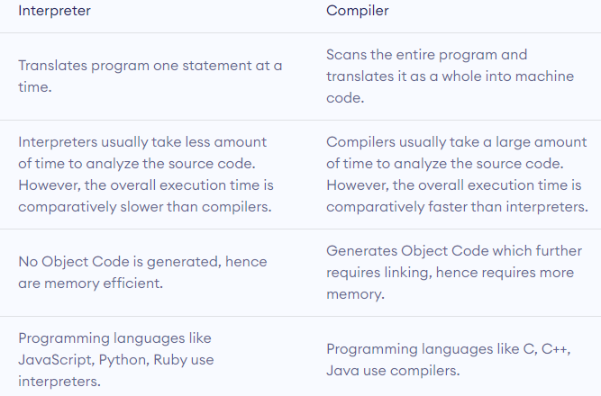

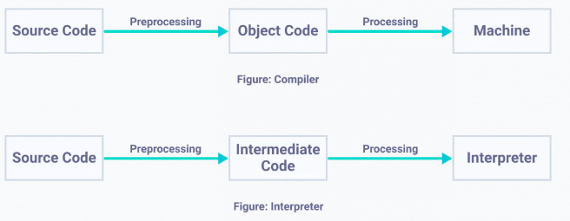

Object Code :

Object code refers to low level code which is understandable by machine. Object code is generated from source code after going through compiler or other translator. It is in executable machine code format. Object code contains a sequence of machine understandable instructions to which Central Processing Unit understands and executes.

Object file contains object code. It is considered as one more of machine code. Some object file examples are common object file format (COFF), COM files and “.exe” files.

Intermediate Code: